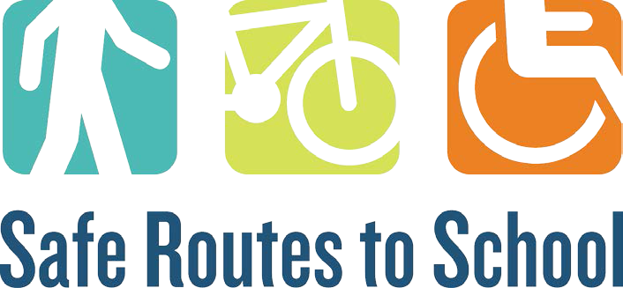

Request for Mini Grant Proposals for

**Safe Routes to School Active Transportation Programs**

**SECTION G. SIGNATURES**

Applicant Signature:

Date: __

Principal Signature:

Date: _

District Administrator Signature: Date: ________________________

**If applying for multiple schools, please use the additional principal signature lines below or principals can send an e-mail conveying their support of the program to** [**epaskus@michiganfitness.org**](mailto:epaskus@michiganfitness.org)

Principal Signature:

Date:

Principal Signature:

Date:

Principal Signature:

Date:

Principal Signature:

Date:

rev. 1/15/2020 1