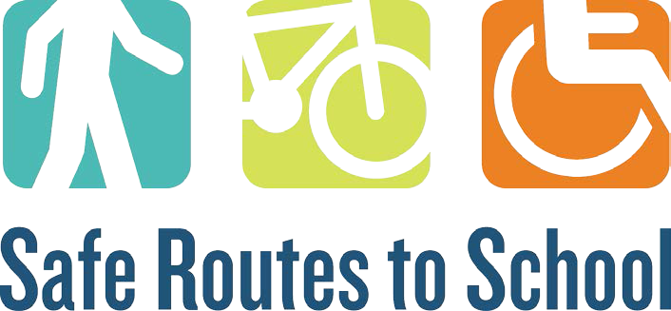

Request for Mini Grant Proposals for
Safe Routes to School Active Transportation Programs

SECTION G. SIGNATURES

Applicant Signature:
Date: __

Principal Signature:

Date: _

District Administrator Signature: Date: ________________________

If applying for multiple schools, please use the additional principal signature lines below or principals can send an e-mail conveying their support of the program to epaskus@michiganfitness.org

Principal Signature:

Date:

Principal Signature:

Date:

Principal Signature:

Date:

Principal Signature:

Date:

rev. 1/15/2020 1

