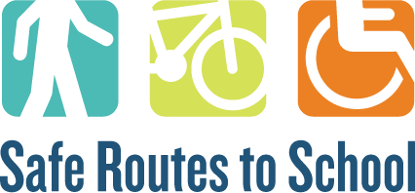
School(s) Action Plan
School(s): ______________________________________________________________________________________
Date: _________________________________________________________________________________________

SRTS Action Plan
Now that you’ve completed the audit(s) and have the results from the surveys, you will meet as a committee to discuss what barriers to walking and biking to school you found and come up with solutions for those barriers.
As the last step in the SRTS planning process, the action plan is meant to be a guide for your overall SRTS process. You can include solutions to barriers here that you might not include in the application. The point is to think of all opportunities, not just those that can be funded from the Federal SRTS grant. Include both long- and short-term objectives, objectives that can be completed through SRTS funds and those that cannot. You do not need to put everything from the action plan into the application, but everything that is listed in the application, should be in the action plan.
How do you complete the action plan?
- Gather Your Team
  - This can be completed over several committee meetings.
  - Invite experts (e.g. engineers, educators, local planners) to discuss and identify specific projects to include in the Action Plan.
- Review Goals and Data
  - The vision for Safe Routes to School (e.g. more students walking and bicycling on safe routes.)
  - The Six E’s for a comprehensive SRTS approach.
  - The physical and psychological barriers to walking and/or bicycling to school that were identified in the surveys or found during the walking and/or bicycling audit.
- Make a Plan
  - Fill out the tables below for both the programming recommendations and the infrastructure recommendations. Reference the E’s, data from the walking audits, surveys, and meetings to support the reasoning for the recommendation.

NON-INFRASTRUCTURE
PROGRAM | PROBLEM / CONCERN | OUTCOME | PROGRAM LEADER | PROGRAM SUPPORT | PRIORITY | SCHOOLS
Provide a brief description of the program you’d like to implement. | What problem, issue, or gap will this program address? Use surveys, travel tallies, and input from meetings for why this is changing. | Discuss why this program is important, how will it help students get to school safely? | Enter lead organization/individual | Enter support organization/individual | Short term (1-2 years); Medium term (2-4 years); or Long term (4+ years) | Which school or schools will this impact (if multiple schools)?
Program 1

Program 2

Program 3

Program 4

Program 5

Program 6

INFRASTRUCTURE
 | LOCATION | PROBLEM/ISSUE | POTENTIAL SOLUTION/RECOMMENDATON | ANTICIPATED OUTCOME | LEAD CONTACT / AGENCY | PRIORITY (low/medium/high)
A | Provide street to cross streets, intersection, or other identifying features | Discuss the problem / issue students face getting to school at that location | Explain the recommendation succinctly | Explain the anticipated positive outcome for students | Enter lead contact | Explain the priority for this outcome
B

C
D
E
F
G

